ICT - Lab

Sumário

Kits NXP 2

**Características** 2

**Aplicações** 4

Intel Develp kit shell bay fab 2 6

**Features** 6

**Interfaces** 7

**Block diagram** 8

**Kits NXP**

LPC1769/68/67/66/65/64/63

**Características**

* ARM Cortex-M3 processor, running at frequencies of up to 100 MHz or of up to 120 MHz. A Memory Protection Unit (MPU) supporting eight regions is included.
* ARM Cortex-M3 built-in Nested Vectored Interrupt Controller (NVIC).
* Up to 512 kB on-chip flash programming memory. Enhanced flash memory accelerator
* Enables high-speed 120 MHz operation with zero wait states.
* In-System Programming (ISP) and In-Application Programming (IAP) via on-chip bootloader software.
* On-chip SRAM includes:
  + 32/16 kB of SRAM on the CPU with local code/data bus for high-performance CPU access.
* Two/one 16 kB SRAM blocks with separate access paths for higher throughput. These SRAM blocks may be used for Ethernet, USB, and DMA memory, as well as for general purpose CPU instruction and data storage.
* Eight channel General Purpose DMA controller (GPDMA) on the AHB multilayer matrix that can be used with SSP, I2S-bus, UART, Analog-to-Digital and Digital-to-Analog converter peripherals, timer match signals, and for memory-to-memory transfers.
* Multilayer AHB matrix interconnect provides a separate bus for each AHB master. AHB masters include the CPU, General Purpose DMA controller, Ethernet MAC, and the USB interface. This interconnect provides communication with no arbitration delays.
* Split APB bus allows high throughput with few stalls between the CPU and DMA.
* Serial interfaces:
  + Ethernet MAC with RMII interface and dedicated DMA controller.
  + USB 2.0 full-speed device/Host/OTG controller with dedicated DMA controller and on-chip PHY for device, Host, and OTG functions.
  + Four UARTs with fractional baud rate generation, internal FIFO, and DMA support. One UART has modem control I/O and RS-485/EIA-485 support, and one UART has IrDA support.
  + CAN 2.0B controller with two channels.
  + SPI controller with synchronous, serial, full duplex communication and programmable data length.
  + Two SSP controllers with FIFO and multi-protocol capabilities. The SSP interfaces can be used with the GPDMA controller.
  + Three enhanced I2C bus interfaces, one with an open-drain output supporting full I2C specification and Fast mode plus with data rates of 1 Mbit/s, two with standard port pins. Enhancements include multiple address recognition and monitor mode.
  + I2S (Inter-IC Sound) interface for digital audio input or output, with fractional rate control. The I2S-bus interface can be used with the GPDMA. The I2S-bus interface supports 3-wire and 4-wire data transmit and receive as well as master clock input/output.
* Other peripherals:
  + 70 (100 pin package) General Purpose I/O (GPIO) pins with configurable pull-up/down resistors. All GPIOs support a new, configurable open-drain operating mode. The GPIO block is accessed through the AHB multilayer bus for fast access and located in memory such that it supports Cortex-M3 bit banding and use by the General Purpose DMA Controller.
  + 12-bit Analog-to-Digital Converter (ADC) with input multiplexing among eight pins, conversion rates up to 200 kHz, and multiple result registers. The 12-bit ADC can be used with the GPDMA controller.
  + 10-bit Digital-to-Analog Converter (DAC) with dedicated conversion timer and DMA support.
  + Four general purpose timers/counters, with a total of eight capture inputs and ten compare outputs. Each timer block has an external count input. Specific timer events can be selected to generate DMA requests.
  + One motor control PWM with support for three-phase motor control.
  + Quadrature encoder interface that can monitor one external quadrature encoder.
  + One standard PWM/timer block with external count input.
  + RTC with a separate power domain and dedicated RTC oscillator. The RTC block includes 20 bytes of battery-powered backup registers.
  + WatchDog Timer (WDT). The WDT can be clocked from the internal RC oscillator, the RTC oscillator, or the APB clock.
  + ARM Cortex-M3 system tick timer, including an external clock input option.
  + Repetitive interrupt timer provides programmable and repeating timed interrupts.
  + Each peripheral has its own clock divider for further power savings.
* Standard JTAG test/debug interface for compatibility with existing tools. Serial Wire Debug and Serial Wire Trace Port options.
* Emulation trace module enables non-intrusive, high-speed real-time tracing of instruction execution.
* Integrated PMU (Power Management Unit) automatically adjusts internal regulators to minimize power consumption during Sleep, Deep sleep, Power-down, and Deep power-down modes.
* Four reduced power modes: Sleep, Deep-sleep, Power-down, and Deep power-down.
* Single 3.3 V power supply (2.4 V to 3.6 V).
* Four external interrupt inputs configurable as edge/level sensitive. All pins on Port 0 and Port 2 can be used as edge sensitive interrupt sources.
* Non-maskable Interrupt (NMI) input.
* Clock output function that can reflect the main oscillator clock, IRC clock, RTC clock, CPU clock, and the USB clock.
* The Wake-up Interrupt Controller (WIC) allows the CPU to automatically wake up from any priority interrupt that can occur while the clocks are stopped in deep sleep, Power-down, and Deep power-down modes.
* Processor wake-up from Power-down mode via any interrupt able to operate during
* Power-down mode (includes external interrupts, RTC interrupt, USB activity, Ethernet wake-up interrupt, CAN bus activity, Port 0/2 pin interrupt, and NMI).
* Brownout detect with separate threshold for interrupt and forced reset.
* Power-On Reset (POR).
* Crystal oscillator with an operating range of 1 MHz to 25 MHz.
* 4 MHz internal RC oscillator trimmed to 1 % accuracy that can optionally be used as a system clock.
* PLL allows CPU operation up to the maximum CPU rate without the need for a high-frequency crystal. May be run from the main oscillator, the internal RC oscillator, or the RTC oscillator.
* USB PLL for added flexibility.
* Code Read Protection (CRP) with different security levels.
* Unique device serial number for identification purposes.
* Available as LQFP100 (14 mm x 14 mm x 1.4 mm), TFBGA1001 (9 mm x 9 mm x 0.7 mm), and WLCSP100 (5.074  5.074  0.6 mm) package

**Aplicações**

* *eMetering*
* *Lighting*
* *Industrial Networking*
* *Alarm Systems*
* *White Goods*
* *Motor Control*

**Diagrama de blocos**

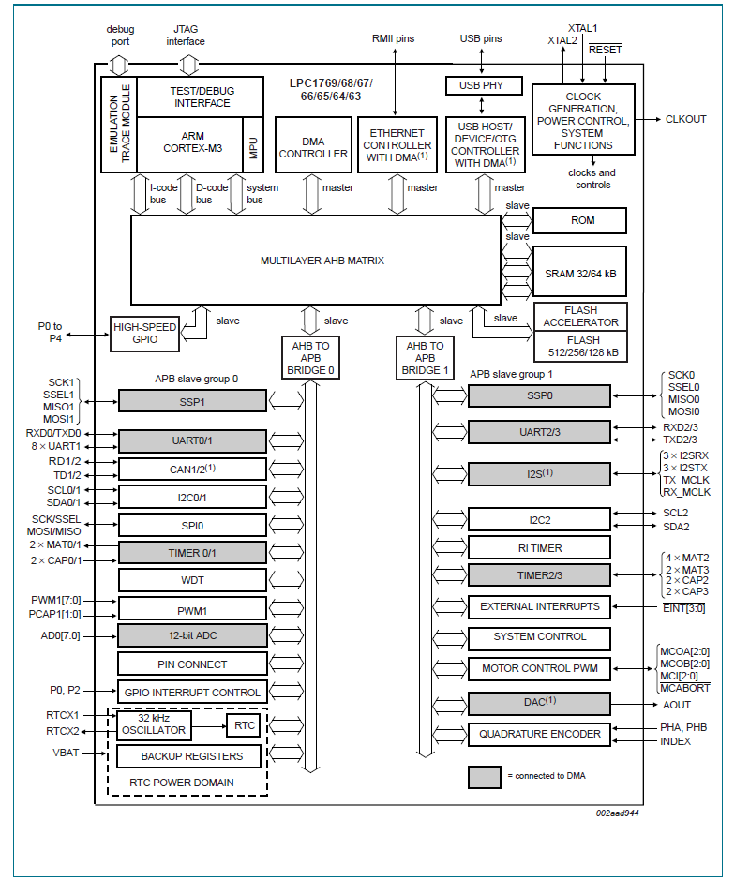

**Intel Develp kit shell bay fab 2**

Figura 1 - Diagrama de blocos NXP

Intel Atom Processor E660 with Intel Platform Controller Hub EG20T Development Kit

**Features**

* COM Express Module with Intel Atom Processor E660, 1GB DDR2 soldered down memory, system management CPLD and SPI Flash. (Supports DDR2 soldered down memory. Supports 800 MHz memory bus frequencies).
* Carrier board with the Intel® Platform Controller Hub EG20T and other system components and peripheral connectors for PCIe*, PCI, SDVO, SATA, USB, LAN, LVDS, SD/SDIO/MMC, UART and audio interfaces.
* Timesys Fedora* Remix Linux operating system (pre-installed on the hard drive included in the kit)
* Software CD with user’s guide, reference design materials, drivers and utilities
* SATA Gen2 hard drive
* USB floppy drive
* Power supply
* LVDS cable

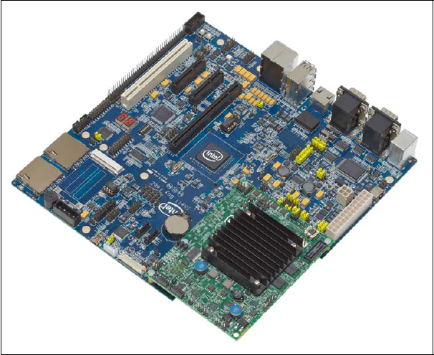

**Figura 2 - Intel Shell Bay Fab2**

**Interfaces**

* Interface to processor of PCI Express x1 lane (Gen1)
* One GMAC interface for Gigabit Ethernet
* Two SATA ports, Gen2
* Six USB 2.0HS Host compatible ports
* One USB 2.0HS Client compatible port
* Two SDIO/MMC interfaces
* Four UART interfaces
* One CAN interface
* One Serial Peripheral Interface (SPI)
* One I2C* interface
* One 12-bit GPIO interface
* One SPI Serial ROM interface

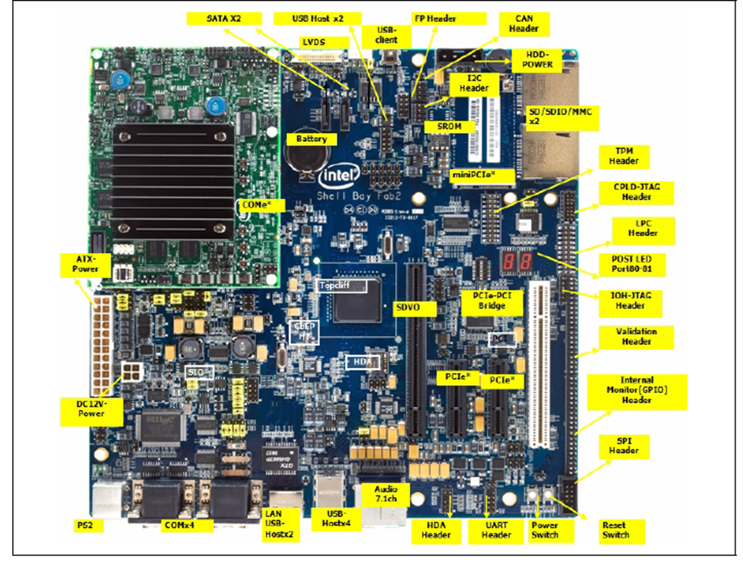

Figura 3 - Interfaces Shell Bay Fab2

**Block diagram**

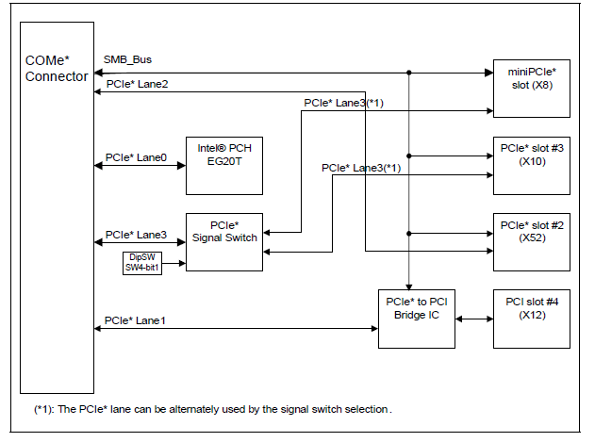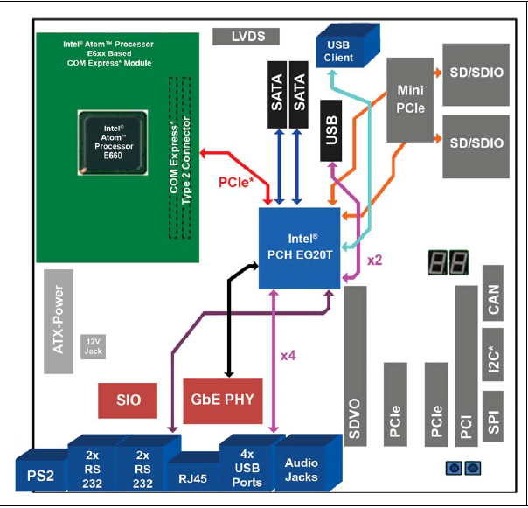

Figura 5 - Diagrama de blocos PCI Express

Figura 4 - Diagrama de blocos Shell Bay Fab2